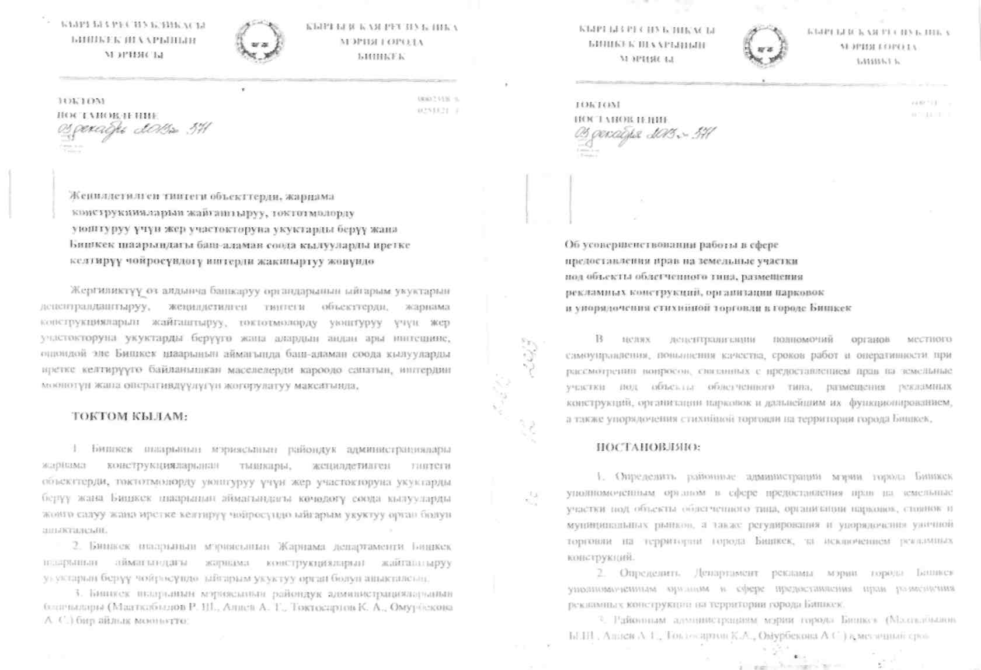

,"«2Wt :_.
'♦ -. 5 I

